This document shows how to register your non-Volusia County Schools student to enable you to complete an application for one of our programs: CTE, Cambridge AICE, or IB.
Before you can complete an application your student, you must first create a FOCUS Parent Portal account.
For the protection of your student’s confidential information, we have created the following secure procedures. A valid email address is needed to create your FOCUS Parent Portal account and will become your portal username.
Go to the district website https://www.vcsedu.org/ , select the Parents tab, then Parent Portal Or go directly to https://volusia.focusschoolsoftware.com/focus/auth
- Click the option to create a Focus Parent Portal account
- Enter the Parent/Guardian information in all the required fields
  - Enter the Parent/Guardian First Name as it appears on your Driver’s License
  - Enter the Parent/Guardian Last Name as it appears on your Driver’s License
  - Enter a valid Email Address, this email address will be your username
(VCS employees use a personal email address and not your VCS issued email)
  - Create Password to sign into the Volusia Parent Portal
  - Retype Password to verify the password
  - Check the box I’m not a robot
  - Click Submit
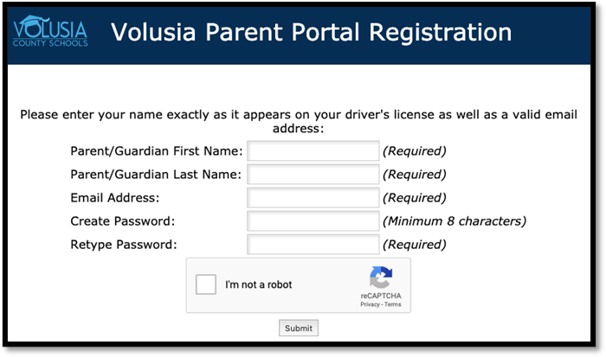

- Click I would like to APPLY FOR ENROLLMENT for a new child
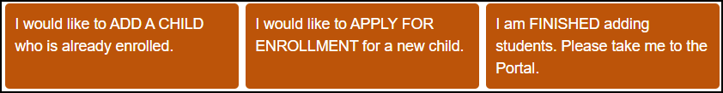

- Enter the Student’s First Name, Student’s Last Name, and Student’s Birthdate, then click Begin Application
Note: The field labeled “Language” is the language available for viewing the application
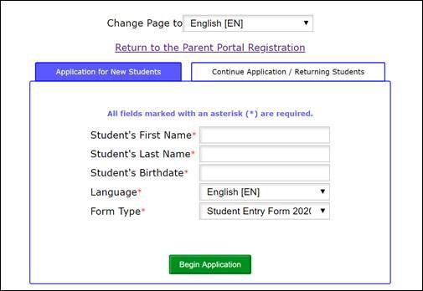

- You will then see Apply for Enrollment Student Entry Form 2021-2022, follow the instructions within the enrollment application to complete and submit
- You may save your progress in the application. Should you need to return at a later time to complete the enrollment, go to https://volusia.focusschoolsoftware.com/focus/apply/ and select Continue Application / Returning Students

