Deland High School

Avant Garde Dance Auditions

May 16-18, 2023
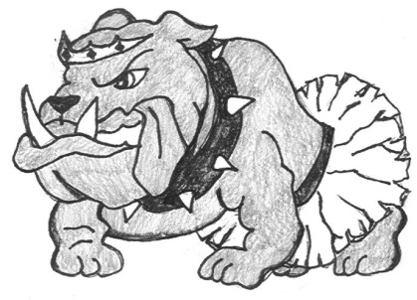

Please join jour Band App for audition updates, music, videos and more!

Avant Garde Criteria:
- Open to grade levels 9-12
- No 3’s in conduct, excessive referrals, tardies or absences
- 2.5 G.P.A. (Copy of 3rd quarter report card)
- Registration form
- Team Fee sheet
- Teacher recommendations x3
- FHSAA – Consent & Liability Waiver
- Good Attendance
- Able to commit to team involvement for 1 year

Audition Week:
Tuesday, May 16, 2023 – Dance Instruction 4:30 – 7:00 Dance Room
Wednesday, May 17, 2023 – Dance Instruction 3:30 – 6:00 Dance Room
Thursday, May 18, 2023 – Auditioned Adjudication 4:30 – 7:00 Dance Room
Friday, May 19, 2023 – Final castings will be posted in the front office,
on the dance room door, and school web site at the end of the school day.
Thursday, May 25, 2023 – Information meeting & uniform fitting for
2023 - 2024 Avant Garde team members 4:30 – 6:00 - Dance Room (Bldg. 13-109)

For more details contact Mrs. Gleason 822-6909 ext. 23346
Or email at hbgleaso@volusia.k12.fl.us

Deland High School
800 N. Hill Ave.
Deland, FL 32724
Avant Garde Dance Candidate Criteria

All candidates must secure the following information by Thursday, May 25, 2023. Late paper work will result in a loss of 10 responsibility points per day. Candidates missing their FHSAA form, application, and fee sheet will not be permitted to attend the final day of adjudication on Thursday, May 18, 2023.

- Completed application with parent/guardian signature
- FHSAA consent & release form
- Agree to pay membership fees (Thursday, May 25, 2023 – 1st payment due $100)
- Copy of 3rd quarter report card or proof of 2.5 cumulative un-weighted GPA
- No excessive or serious discipline referrals
- No excessive absences or tardy’s to class
- 3 teacher recommendations
- Must be able to commit to rehearsal schedule & attend Avant Garde activities & performances. Weekly rehearsal schedule: Monday 3:30 – 6:30 p.m. (Building 13 room 109). The after school rehearsal schedule will be adjusted as needed for upcoming performances. Spacing for performances typically occur on Wednesdays ER from 2:30 – 3:30 / non-ER 3:30 – 4:30 and performances usually fall on Thursdays 5:30 – 9:00pm
- Avant Garde, 23-24 team members will be placed in the Avant Garde Dance elective period next school year (schedules permitting). Traditionally offered 7th period.

DHS Avant Garde dance team is holding auditions for the 2023-2024 season! Auditions are open to all grade levels and will take place in the Dance Room, Building 13 Room 109 beginning Tuesday (5/16/23) through Thursday (5/18/23). Students will learn required audition choreography on Tuesday (5/16/23) & Wednesday (5/17/23) from 4:30 – 7:00 p.m. Auditions in front of a panel of judges will take place on Thursday (5/18/23) from 4:30 – 7:00 p.m. or until all candidates have been seen. Final castings will be posted on Band App by 6:00 pm on Friday (5/19/23). The first team meeting taking place on Thursday (5/25/23) from 4:30-6:00 p.m. We appreciate your interest in our Avant Garde dance team and wish you the best of luck & a successful 2023-2024 school year!

Scoring Criteria:
Physical appearance = 10 pts. (2 pts. each – black attire, no jewelry, hair secured, makeup, posture /10pts)
4 Judges Scores = 120 pts. (3 phrases ___/10 pts each x 4 judges =___/120 pts)
3 Teacher References = 50 pts. (Averaged)
Responsibility Points = 20 pts. (- 10 points per day on late/ missing paper work)
Total score = _____/ 200 pts. possible

A panel of 4 judges will score candidates on 3 different routines using a scale of 1-10. Judges scores will reflect upon each dancer’s execution, showmanship, memory of sequence, timing, and spatial awareness within their group. Choreography will vary in styles ranging from modern, ballet, jazz, hip-hop, musical theater, kick / pom. Students are expected to wear all black (leotard and tights, leggings, shorts, etc.) on May 18th for the judging process. Dancer’s hair should be secured out of the face and dancers may wear dance shoes or dance barefoot. Auditions are closed to the public with only the judges, director, administrator, and necessary personnel.

Required dance skills:

- Single outside pirouette in coupe (L & R)
- Single outside pirouette in passe (L & R)
- Grand battement devant (front - L & R)
- Grand battement a la seconde (side – L & R)
- Saut de chat (developed leap) L & R

2023-2024 Avant Garde Audition Registration form:

Name: __________________________________________________________Alpha Code: _______________

Parent/ Guardian names: _____________________________________________________________________

Home Phone #:_______________________________________Work Phone: ___________________________

Student Email: _____________________________________Parent Email: _____________________________

Student Phone: ____________________________________ Parent Phone: _____________________________

Home address: ____________________________________________________________________________

____________________________________________________________________________________

Current Grade: ___________ Birth date (month/day/year): __________________________________________

Current School: _________________________________________________Current GPA: _______________

Health Concerns: ____________________________________________________________________________

Identify school activities / Studio Involvement / Employment: ______________________________________

___________________________________________________________________________________________

Dance experience/ How long/ Where/ Styles studied? :_____________________________________________

____________________________________________________________________________________________________
- Wear comfortable attire that doesn’t restrict movement. Footwear appropriate to the
style of choreography, athletic shoes, or barefoot. All BLACK for adjudication.
- Secure hair away from face, NO Jewelry. Bring a water bottle and towel if needed.
Parent Portion
I realize that the teacher in charge will exercise every precaution for the safety of students involved in this event, and I agree to assume full responsibility for any unforeseen accident which might occur during travel or while participating in this program. I further assure that my son/daughter has been instructed to comply with the regulations of the school, teachers, sponsors, or chaperones that are in charge of this activity. I have provided to the sponsor this SCHOOL-RELATED ACTIVITIES AGREEMENT (Student Information Release Waiver of Liability and Special
Health Information) required by the school and the Volusia County School Board.

___________________________ ___________________________ _______________________
Parent/ Guardian Signature Home Phone Number Emergency Number

Dance Media Release Form
I give my permission for photographs, videos, or television footage to be used for promotional purposes on television, newspapers, magazines or any other media including Volusia County schools publications. I understand the above media will involve no payment of compensation or costs to the participant or parent/ guardian of the participant.
________________________________ ________________________________ ________________
(Signature of parent or guardian) (Signature of student) (Date)

Avant Garde Dance Team Fee List
Below is the list of fees payable to Deland High School for next year’s dance season. Payment of these fees must be made by each due date to have costuming needs included in the order. Returning members may adjust fees according to replacement needs for the new season.

Females Required: Males Required:
Black leggings $ 40 Black joggers $ 40
Black Jazz Dance Sneakers $ 60 Black Jazz Dance Sneakers $ 60
Pink canvas ballet shoes $ 25 Black canvas ballet shoes $ 25
Black spanky shorts $ 25 Dance belt $ 40
Suntan tights(2 pair) $ 30 Black dance short $ 20
Black camisole leotard $ 30 Black dance shirt $ 25
Team Jacket $ 125 Team Jacket $ 125
VCDPA $ 20 VCDPA $ 20
Choreography $ 50 Choreography $ 50
Team Shirt $ 25 Team Shirt $ 25

Female Members Total: $ 430 Male Members Total: $ 430

Dance camp
Opportunities to attend various dance workshops occur throughout the year. Additional fees are required to attend these camps/ workshops. Team fundraising will be done to help offset these expenses, but a portion may be required by the parent. There will be a free MANDATORY Avant Garde Dance Camp lead by the officer line, which typically falls 2-3 weeks prior to school reconvening. Dates and times will be determined at our first team meeting and announced via email after our first officer meeting.

Other required items to be purchased separately by the individual include:
- black & white sports bra
- make-up
- hair supplies
- black socks

Payment Schedule: * Make checks payable to Deland High School
Thursday, May 24, 2023 $100.00
Friday, June 30, 2023 $100.00 Payments can be made in person at rehearsal
Friday, July 28, 2023 $100.00 or checks can be mailed to the school:
Friday, August 25, 2023 $100.00 Deland High School
Friday, September 29, 2023 Balance 800 N. Hill Ave.
Deland FL 32724
Total Fees: $420.00 *Include student name, phone & alpha code

I agree to the list of expenses for Dance Team and will make payments according to the fee schedule. Failure to do so will result in not receiving the required items & benching from the performance. Unpaid fees for items received will also be placed on a student obligation form.
Parent’s signature: ____________________________________________ Date: _____________

Avant Garde Dance Team Fee List
Below is the list of fees payable to Deland High School for next year’s dance season. Payment of these fees must be made by each due date to have costuming needs included in the order. Returning members may adjust fees according to replacement needs for the new season.

Females Required: Males Required:
Black leggings $ 40 Black joggers $ 40
Black Jazz Dance Sneakers $ 60 Black Jazz Dance Sneakers $ 60
Pink canvas ballet shoes $ 25 Black canvas ballet shoes $ 25
Black spanky shorts $ 25 Dance belt $ 40
Suntan tights(2 pair) $ 30 Black dance short $ 20
Black camisole leotard $ 30 Black dance shirt $ 25
Team Jacket $ 125 Team Jacket $ 125
VCDPA $ 20 VCDPA $ 20
Choreography $ 50 Choreography $ 50
Team Shirt $ 25 Team Shirt $ 25

Female Members Total: $ 430 Male Members Total: $ 430

Dance camp
Opportunities to attend various dance workshops occur throughout the year. Additional fees are required to attend these camps/ workshops. Team fundraising will be done to help offset these expenses, but a portion may be required by the parent. There will be a free MANDATORY Avant Garde Dance Camp lead by the officer line, which typically falls 2-3 weeks prior to school reconvening. Dates and times will be determined at our first team meeting and announced via email after our first officer meeting.

Other required items to be purchased separately by the individual include:
- black & white sports bra
- make-up
- hair supplies
- black socks

Payment Schedule: * Make checks payable to Deland High School
Thursday, May 24, 2023 $100.00
Friday, June 30, 2023 $100.00 Payments can be made in person at rehearsal
Friday, July 28, 2023 $100.00 or checks can be mailed to the school:
Friday, August 25, 2023 $100.00 Deland High School
Friday, September 29, 2023 Balance 800 N. Hill Ave.
Deland FL 32724
Total Fees: $420.00 *Include student name, phone & alpha code

I agree to the list of expenses for Dance Team and will make payments according to the fee schedule. Failure to do so will result in not receiving the required items & benching from the performance. Unpaid fees for items received will also be placed on a student obligation form.
Parent’s signature: ____________________________________________ Date: _____________
Parent/ Guardian’s Copy
Avant Garde Dress Code

Rehearsal Attire: Leggings and t-shirt or leotard with tights.
Dancewear colors optional. Appropriate foot wear for choreography.
(Dance specific: ballet shoes, tap shoes, sneakers, or barefoot. No socks)

Performance Attire: DHS warm up jacket with team leotard, team leggings, team earrings, lashes,
black socks, and black jazz sneakers. Costumes will vary from performance to performance & team fundraising will help with these expenses.

All Avant Garde members are responsible for securing the following personal items for rehearsals and performances. All dance wear & rehearsal attire must adhere to the school’s dress code. No midriffs, short shorts, or low tops allowed.

Places to consider when purchasing your attire:

- Dance Depot
1635 Rigewood Ave. Ste. 108
S. Daytona, FL 32119
386-760-4858

- Athletic wear departments in Wal-Mart, Target and sportswear in major department stores.
- Discount Dance Supply 1-800-328-7107 – Teacher Referral Code:TP28072 – receive 10% discount
www.discountdance.com
- Just for Kix Dance Etc. 1-800-762-3347 call for free catalog or visit their website at www.justforkix.com
- Dancewear Solutions 1-866-542-6500 call for free catalog or visit their website at
www.dancewearsolution.com

2023- 2024 Performance Calendar Considerations:
FSA Summer Workshop June 5 – 6, 2023 ($100 additional fee) – optional
Summer fundraiser June/July 2023
Summer Camp August 2023
Homecoming October 2023
FDA Workshop November 2023 (additional fee)
Nursing Home Visits November 2023
Works-in-progress December 2023
Bulldog Palooza January 2024
VCDPA February 2024
Performing Arts Showcase February 2024
Black History Month February 2024
9th grade orientation March 2024
Awards Banquet March 2024
Mr./ Miss DHS April 2024
Renaissance Rally April 2024
Dance Concert April/ May 2024
Avant Garde Auditions May 2024
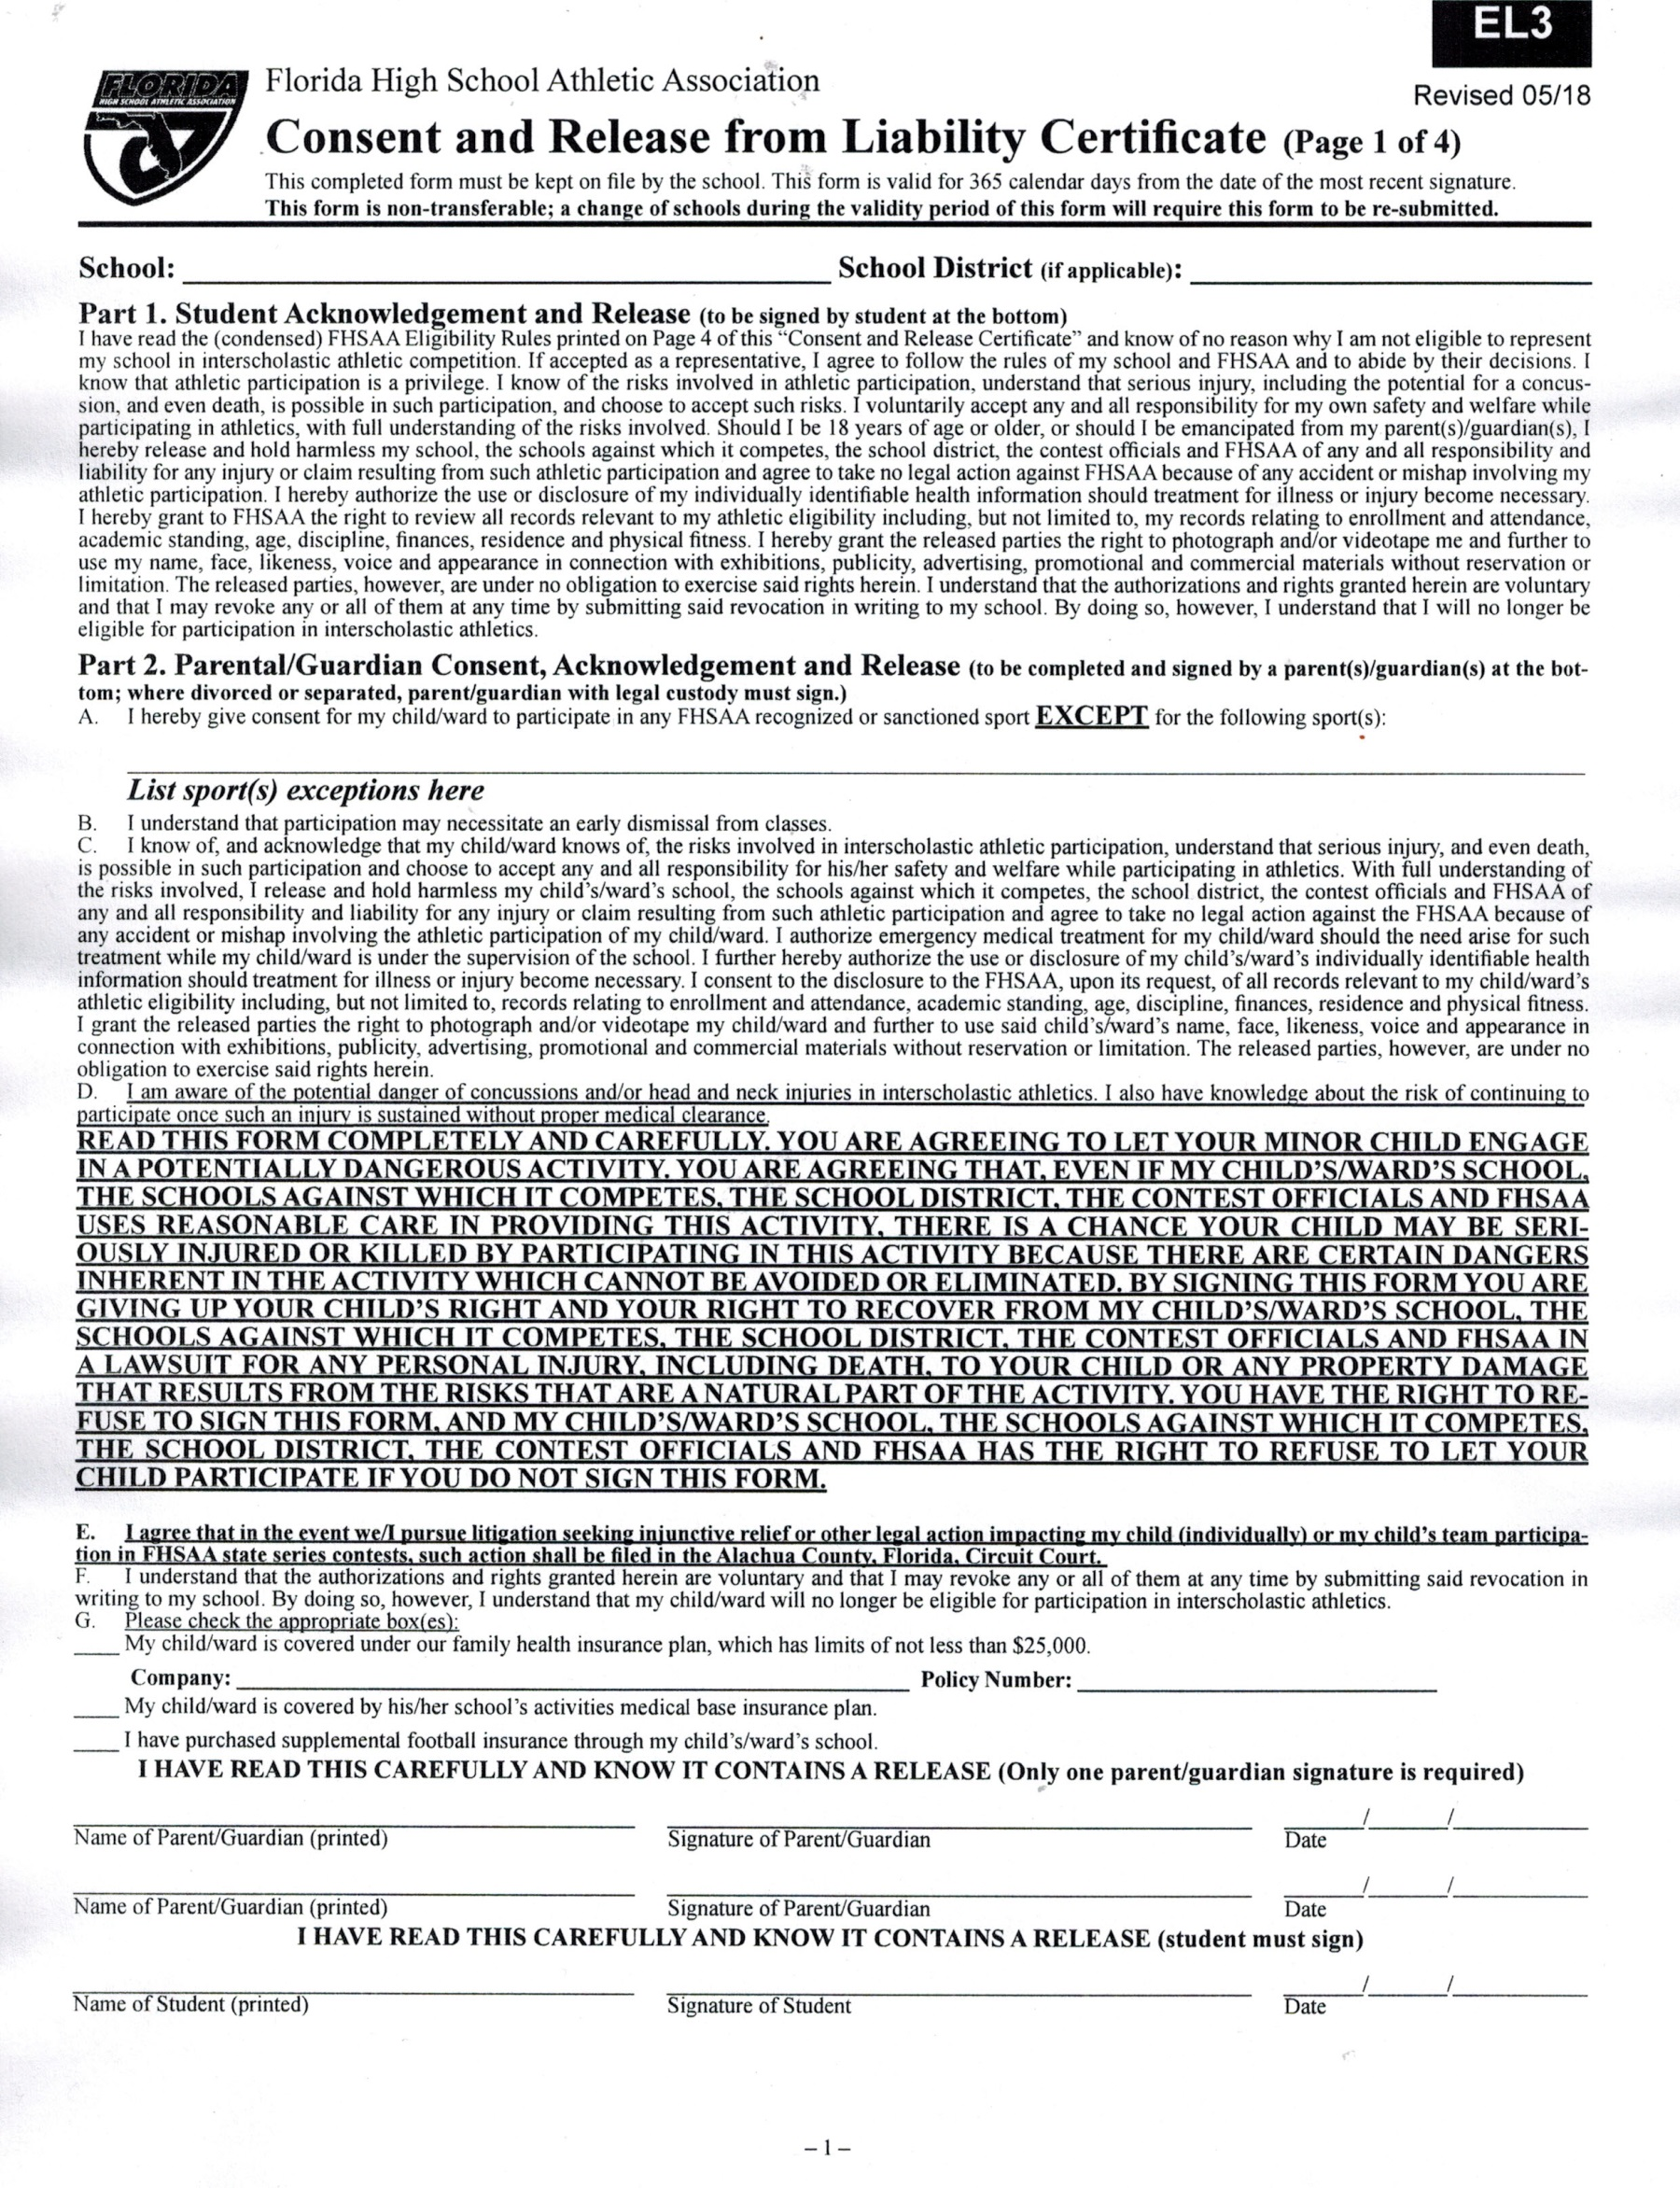

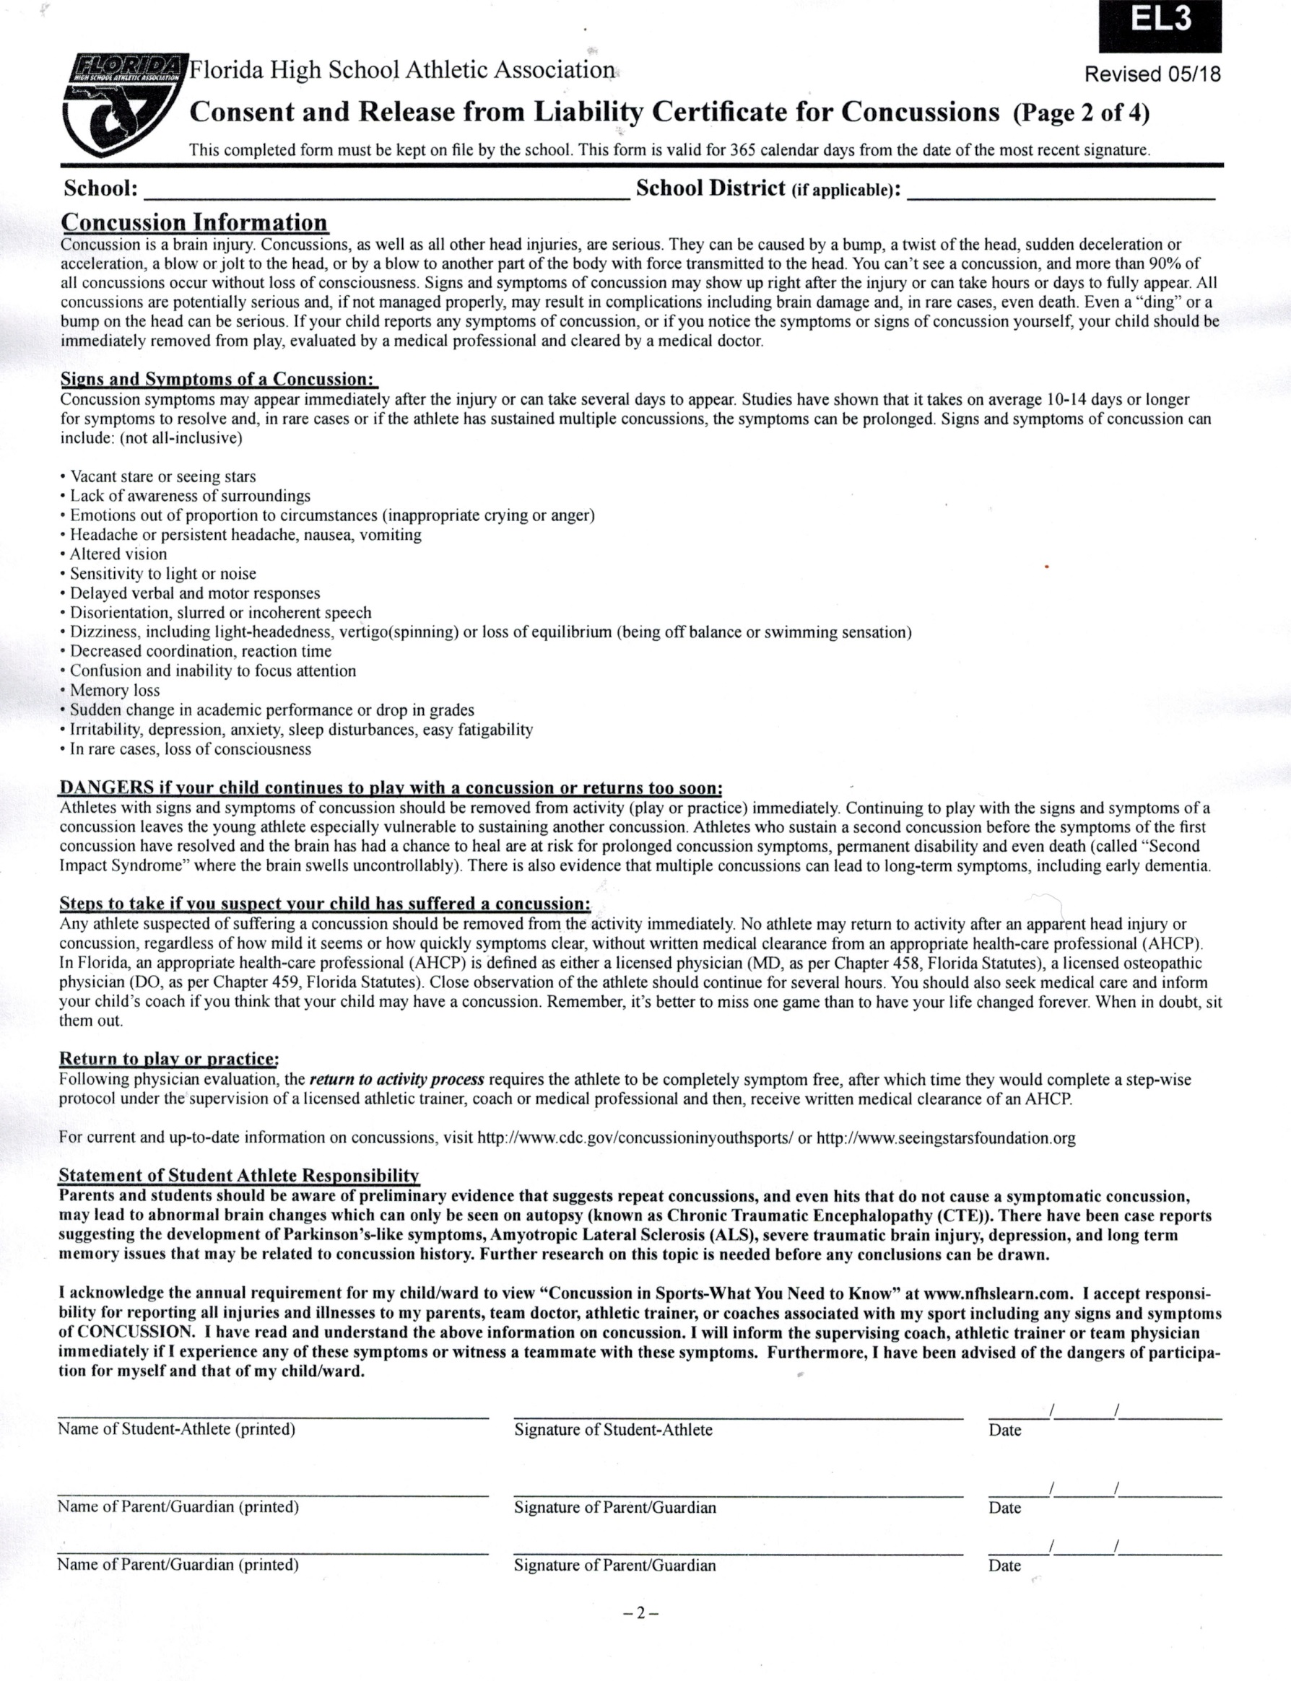

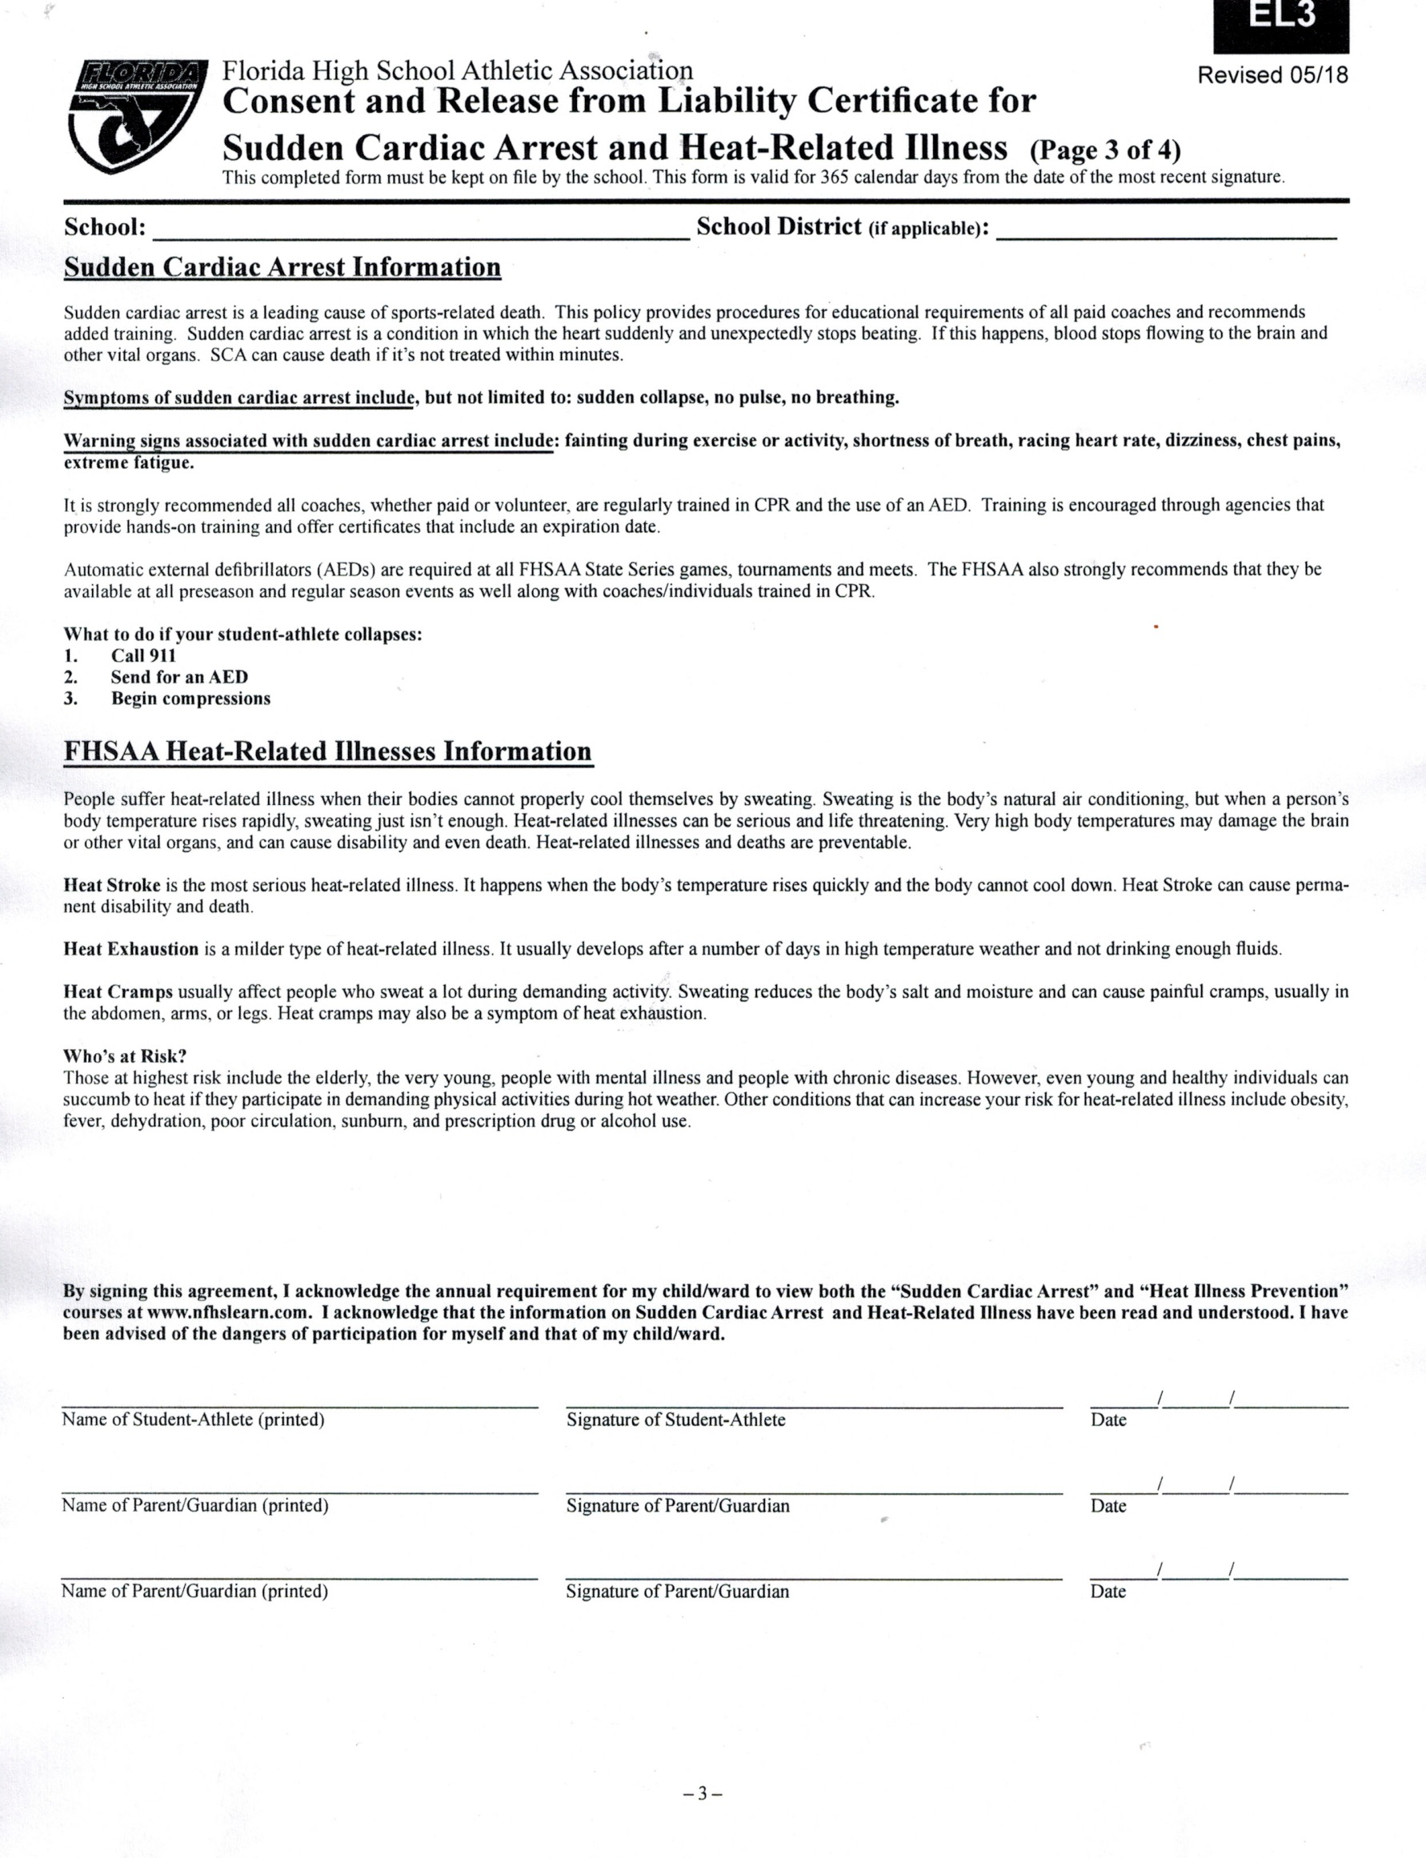

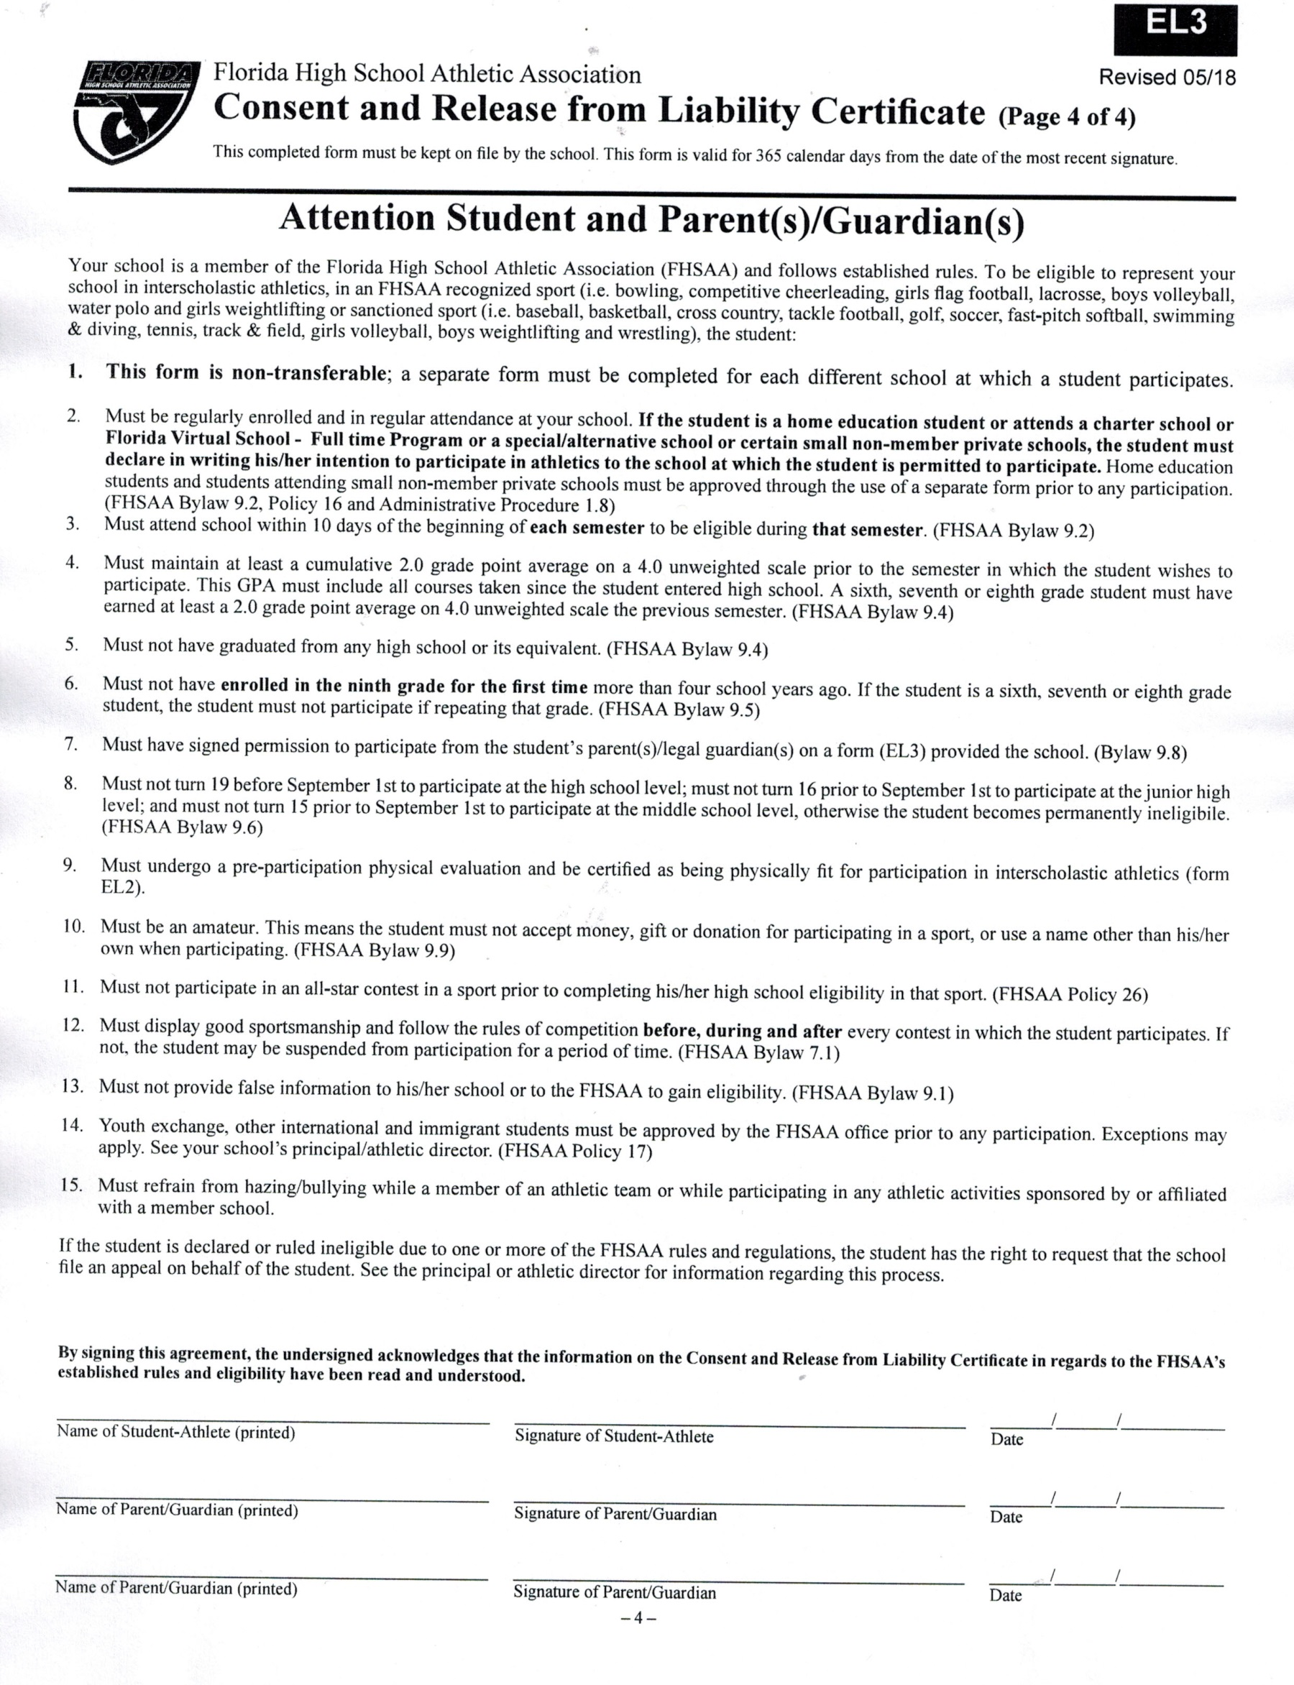

Deland High School’s Avant Garde Dance Ensemble
Teacher Recommendation

Please rate __________________________________________ in the following areas.
(Name of student auditioning)

Teacher/ Subject: _______________________________________________________

Current grade in your class: ___________ Number of days missed this year: _________

Does student display appropriate conduct in your class? Yes _____ No _____

Anything else you feel we should know about this candidate? ______________________
________________________________________________________________________
________________________________________________________________________
________________________________________________________________________
________________________________________________________________________

1=lowest and 5 =highest
Academic achievement 1 2 3 4 5

Ability to work well with others 1 2 3 4 5

Positive attitude 1 2 3 4 5

Respect for authority 1 2 3 4 5

Dependability 1 2 3 4 5

Leadership 1 2 3 4 5

Total: /50 pts.
Maturity 1 2 3 4 5

Meets deadlines 1 2 3 4 5

School spirit 1 2 3 4 5

Attentiveness 1 2 3 4 5

Please return to the student in a signed sealed envelope, if provided by the student, or return to
Heather Gleason’s mailbox located in the front office, Deland High School.
hbgleaso@volusia.k12.fl.us

Thank you for your time and support!

Deland High School’s Avant Garde Dance Ensemble
Teacher Recommendation

Please rate __________________________________________ in the following areas.
(Name of student auditioning)

Teacher/ Subject: _______________________________________________________

Current grade in your class: ___________ Number of days missed this year: _________

Does student display appropriate conduct in your class? Yes _____ No _____

Anything else you feel we should know about this candidate? ______________________
________________________________________________________________________
________________________________________________________________________
________________________________________________________________________
________________________________________________________________________

1=lowest and 5 =highest
Academic achievement 1 2 3 4 5

Ability to work well with others 1 2 3 4 5

Positive attitude 1 2 3 4 5

Respect for authority 1 2 3 4 5

Dependability 1 2 3 4 5

Leadership 1 2 3 4 5

Total: /50 pts.
Maturity 1 2 3 4 5

Meets deadlines 1 2 3 4 5

School spirit 1 2 3 4 5

Attentiveness 1 2 3 4 5

Please return to the student in a signed sealed envelope, if provided by the student, or return to
Heather Gleason’s mailbox located in the front office, Deland High School.
hbgleaso@volusia.k12.fl.us

Thank you for your time and support!

Deland High School’s Avant Garde Dance Ensemble
Teacher Recommendation

Please rate __________________________________________ in the following areas.
(Name of student auditioning)

Teacher/ Subject: _______________________________________________________

Current grade in your class: ___________ Number of days missed this year: _________

Does student display appropriate conduct in your class? Yes _____ No _____

Anything else you feel we should know about this candidate? ______________________
________________________________________________________________________
________________________________________________________________________
________________________________________________________________________
________________________________________________________________________

1=lowest and 5 =highest
Academic achievement 1 2 3 4 5

Ability to work well with others 1 2 3 4 5

Positive attitude 1 2 3 4 5

Respect for authority 1 2 3 4 5

Dependability 1 2 3 4 5

Leadership 1 2 3 4 5

Total: /50 pts.
Maturity 1 2 3 4 5

Meets deadlines 1 2 3 4 5

School spirit 1 2 3 4 5

Attentiveness 1 2 3 4 5

Please return to the student in a signed sealed envelope, if provided by the student, or return to
Heather Gleason’s mailbox located in the front office, Deland High School.
hbgleaso@volusia.k12.fl.us

Thank you for your time and support!

